**Azure Machine Learning Assignment**

1)Navigate to URL, and click on sign in button as show in below figure.

2) Click 🡪 “Enter” on the Guest Workspace, 8-hour trial. This will open to the Experiments Page, like below:-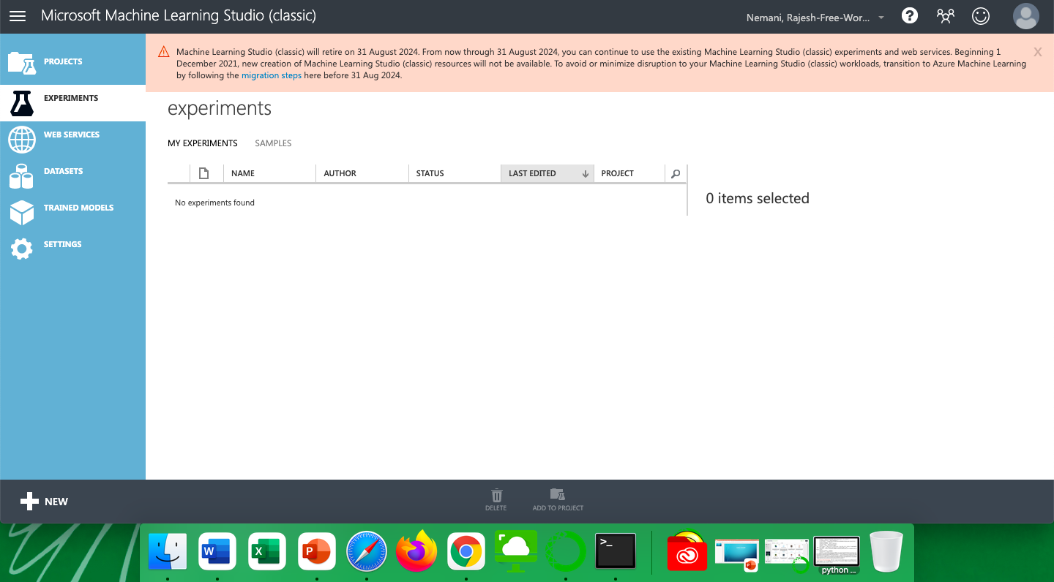

1. Click 🡪 +New which can be found on the left bottom cornor of the page:

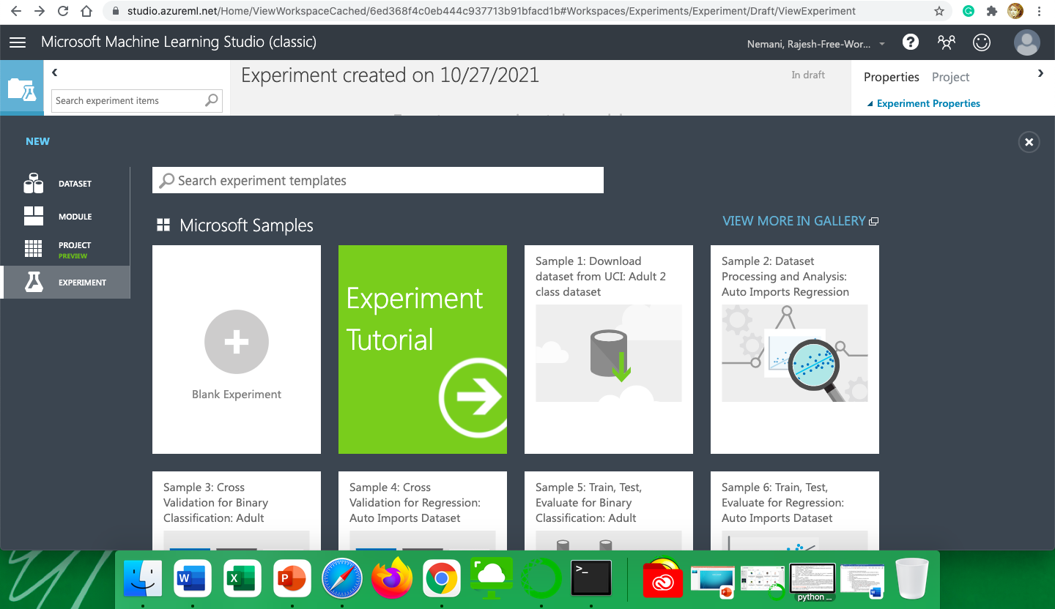

1. Click on Blank Experiment column



1. Click 🡪 Saved Datasets. This will give you a drop-down menu as shown below 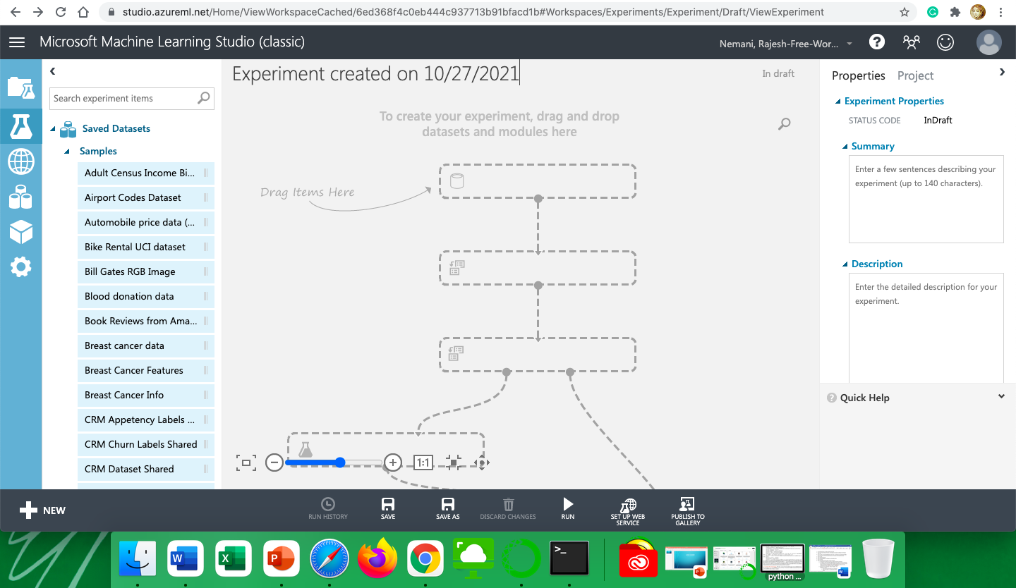
2. Click 🡪 Samples 
3. Drag “Automobile price Data (Raw) “into the workspace.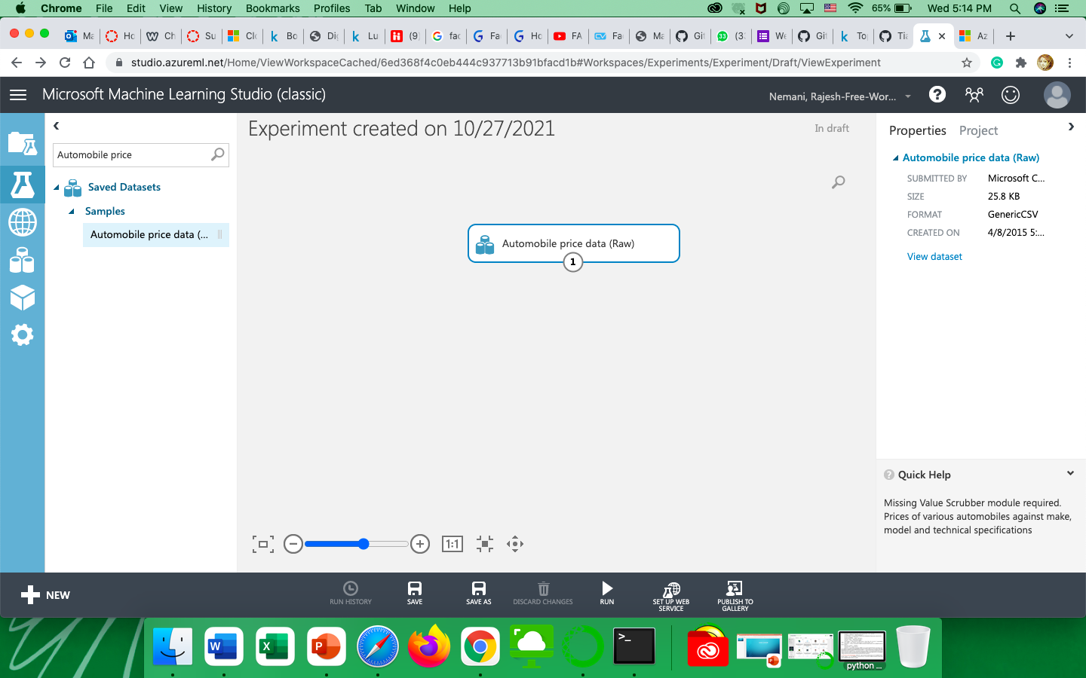
4. By clicking on the output port and selecting visualize we get a pop up that populates the following data from the dataset, for example see the below screenshot: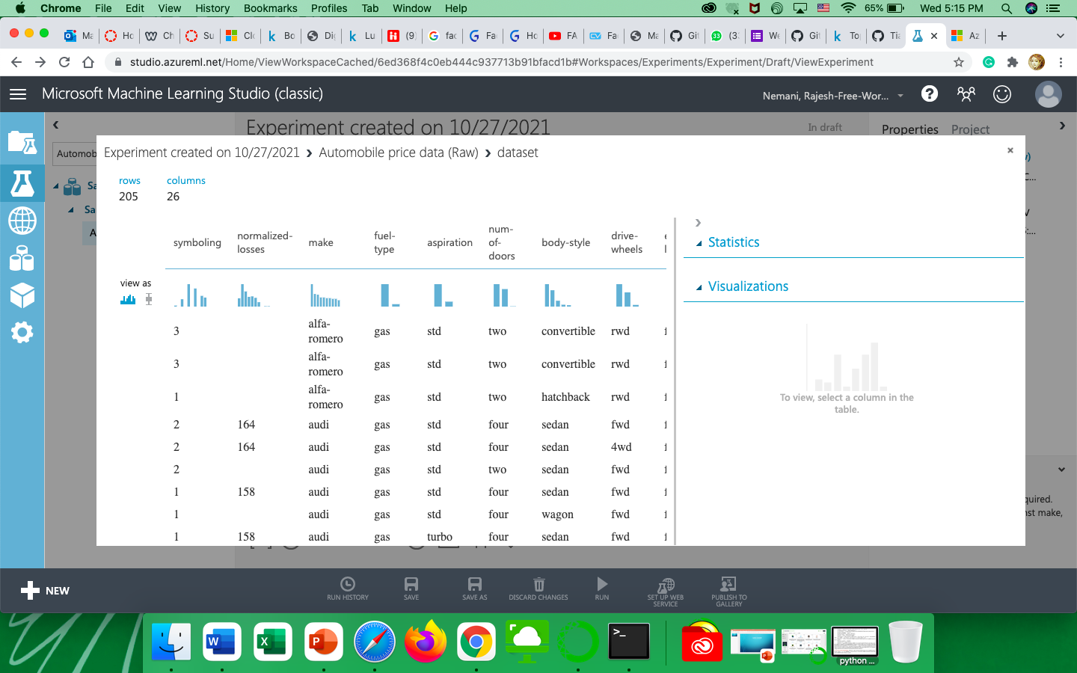

We can even get the statistics of the column like mean, median, minimum values, maximum values, standard deviation, Unique values, missing values, and feature type.

Below we can view the histograms of selected features as well as the stats of those columns.

Stats of the selected columns :

1)Highway-mpg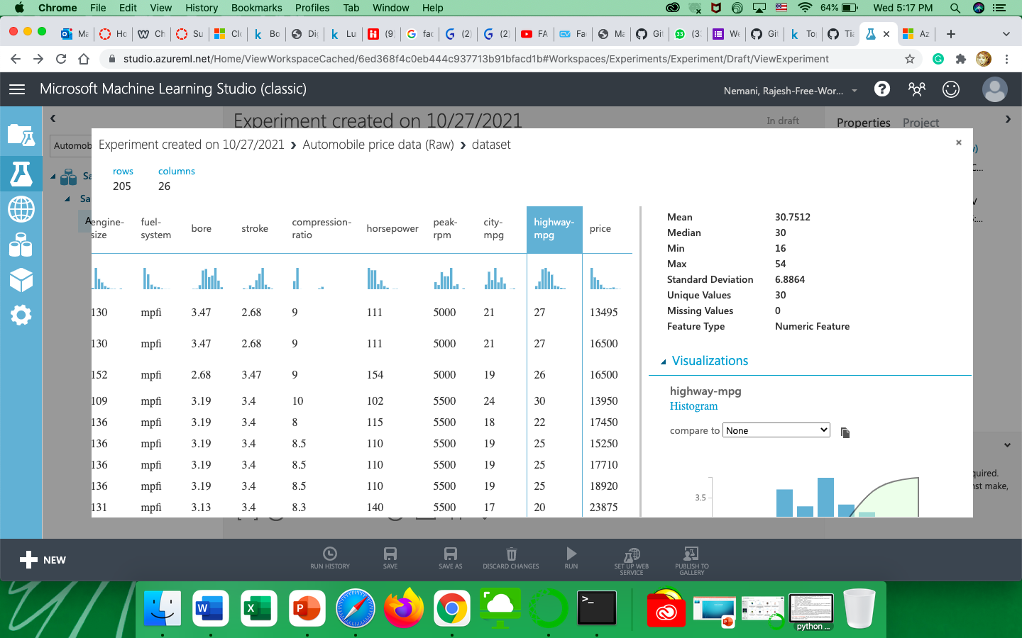

2)Horsepower

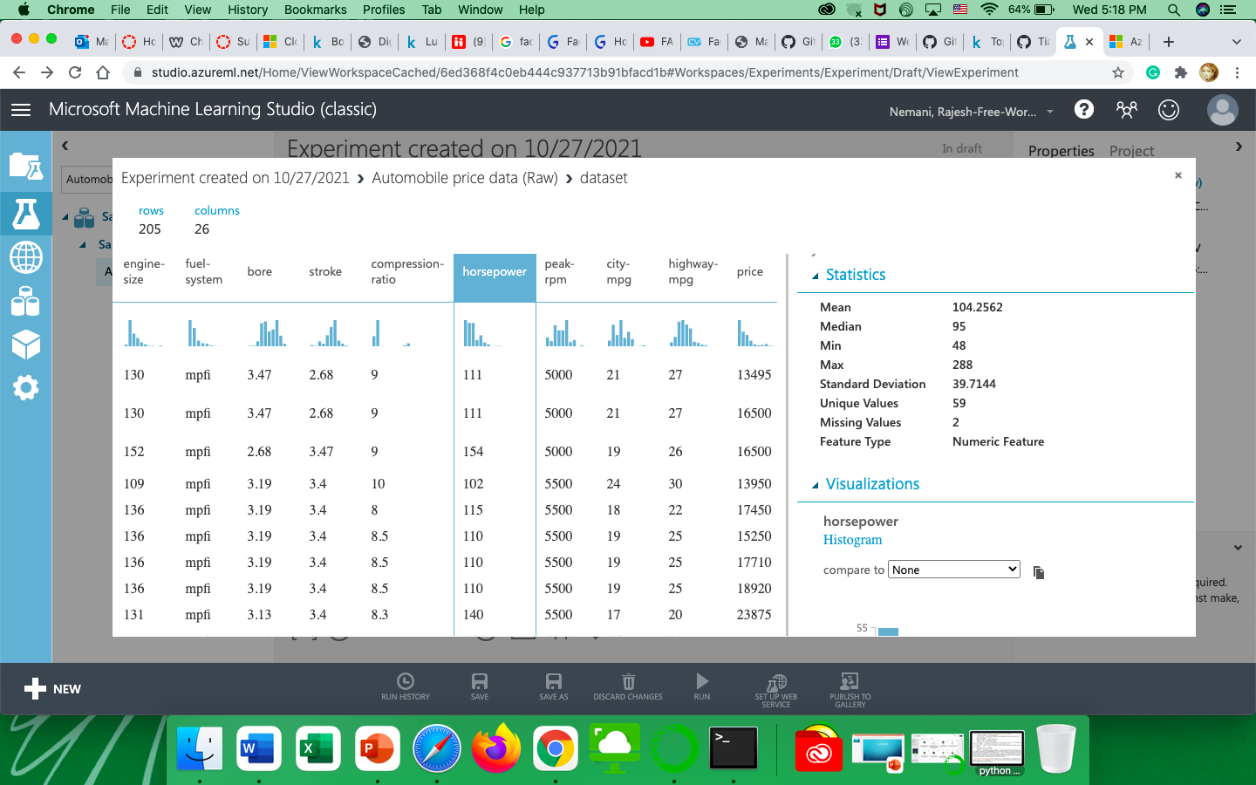

3) Stroke:-

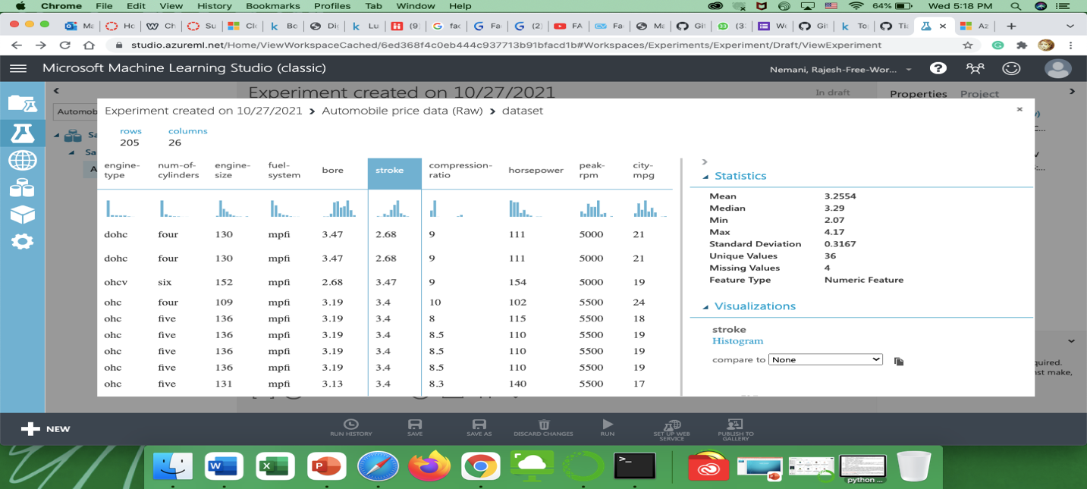

4)Wheelbase:-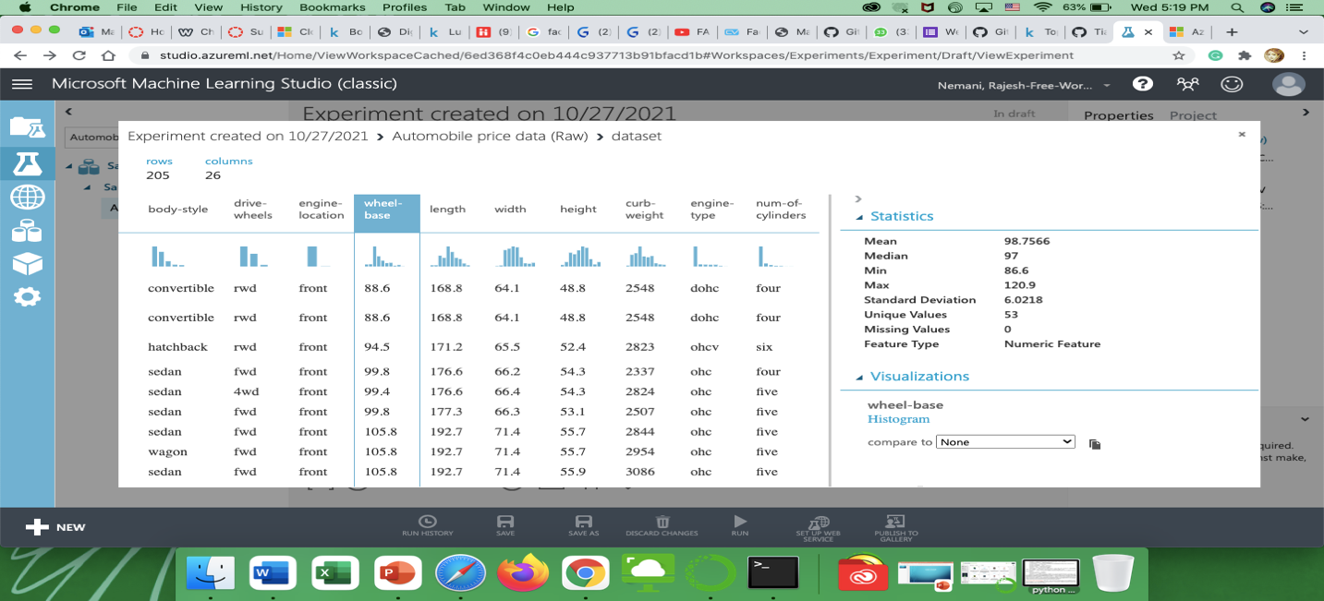

Below are the histogram visualized :

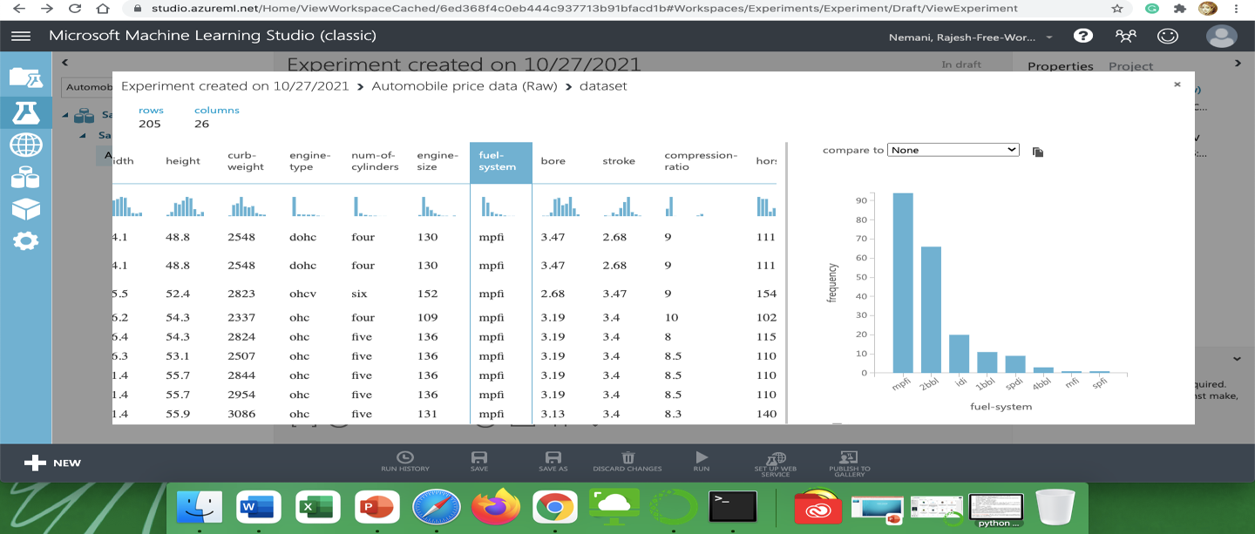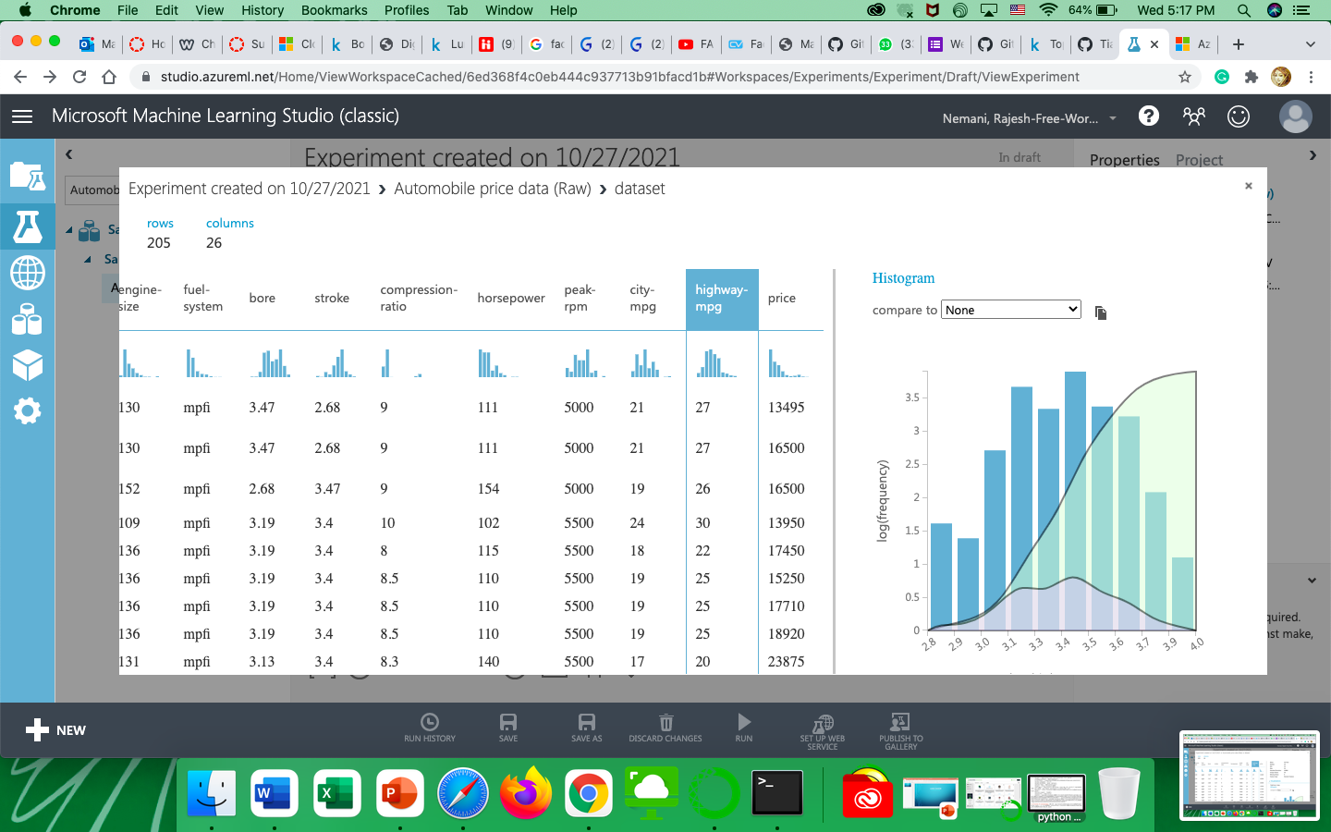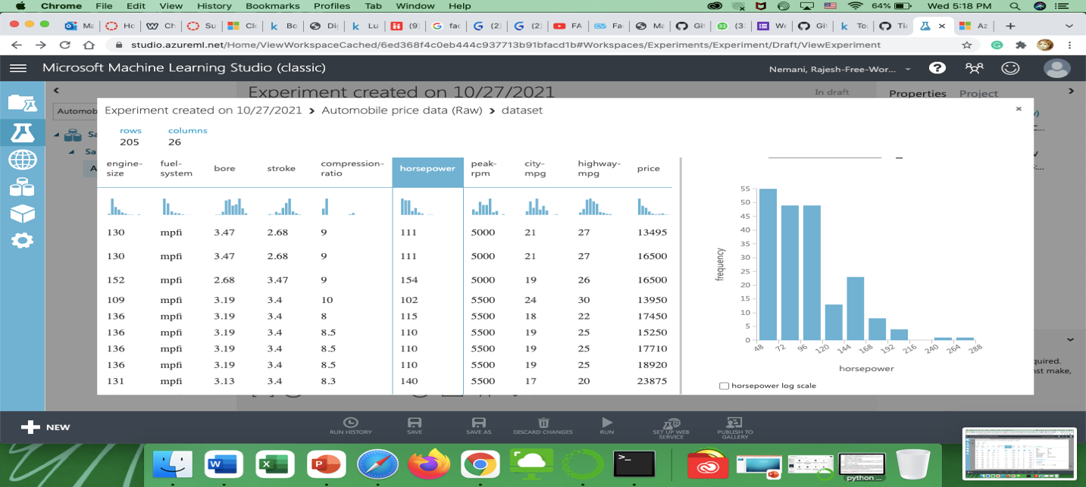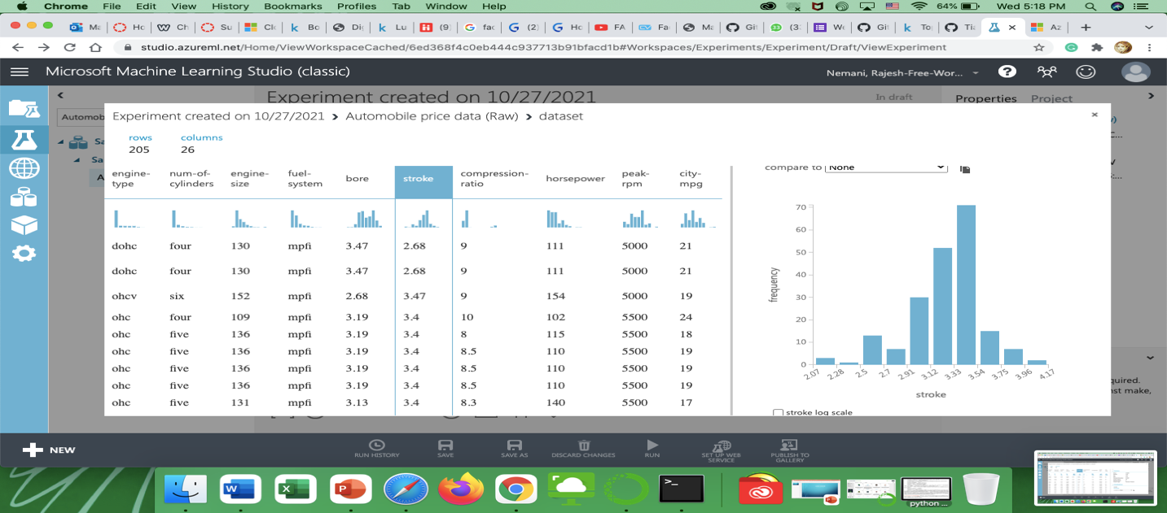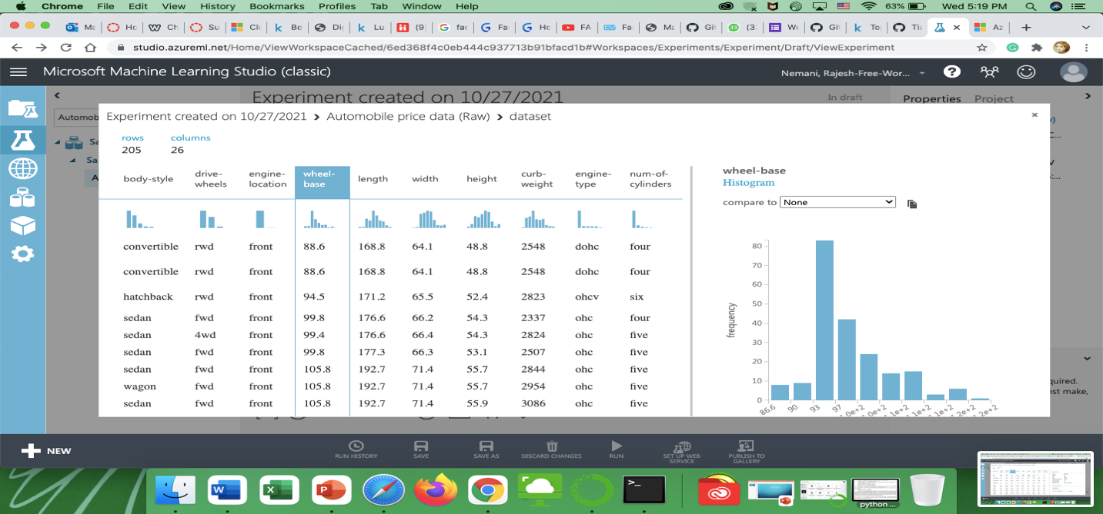

1. We can change the bin size and also apply log to the graph values:-

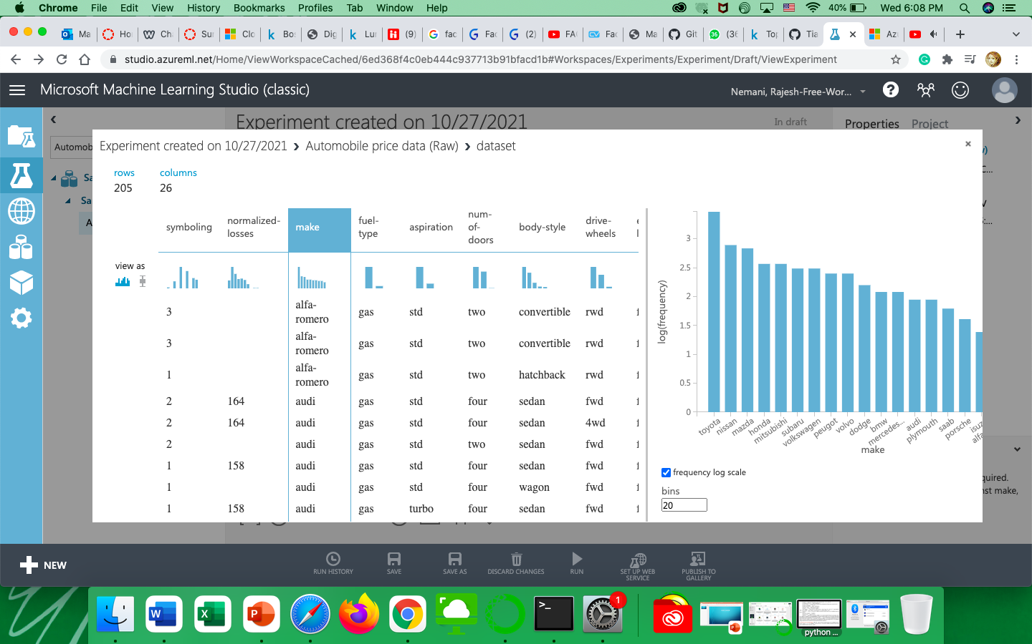

1. Below are the box representation of few features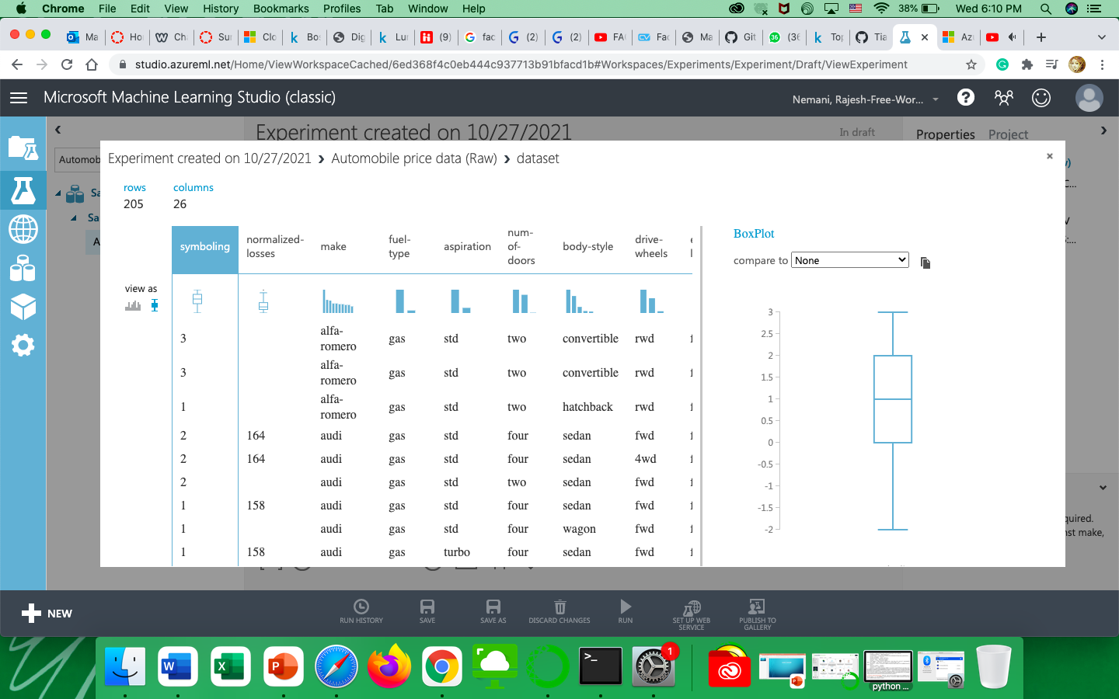

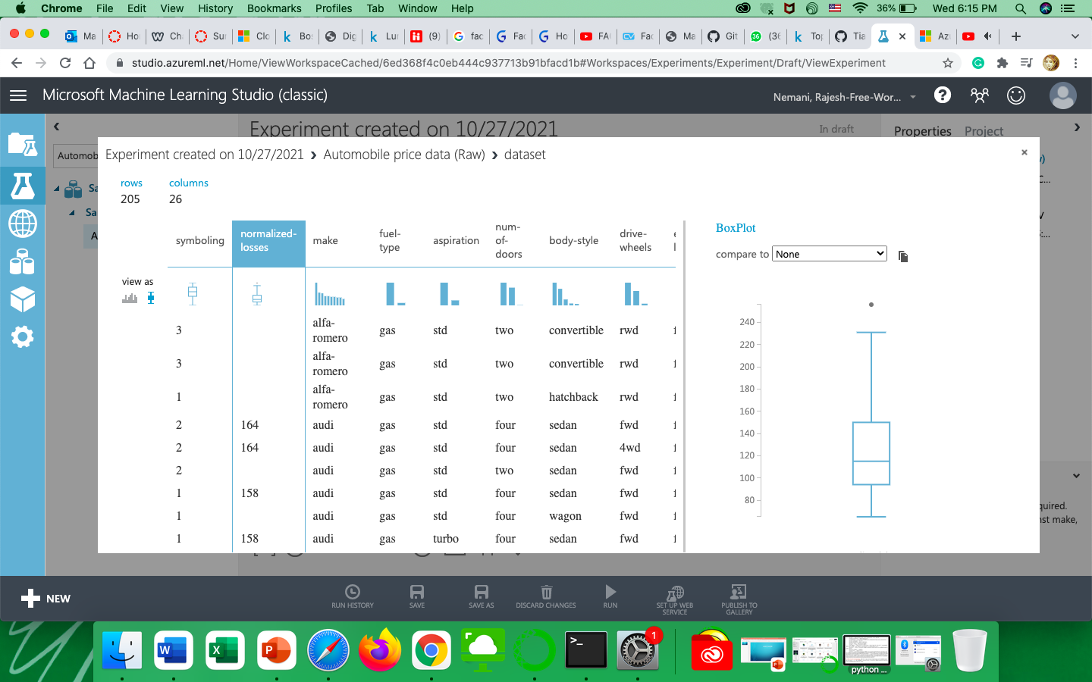

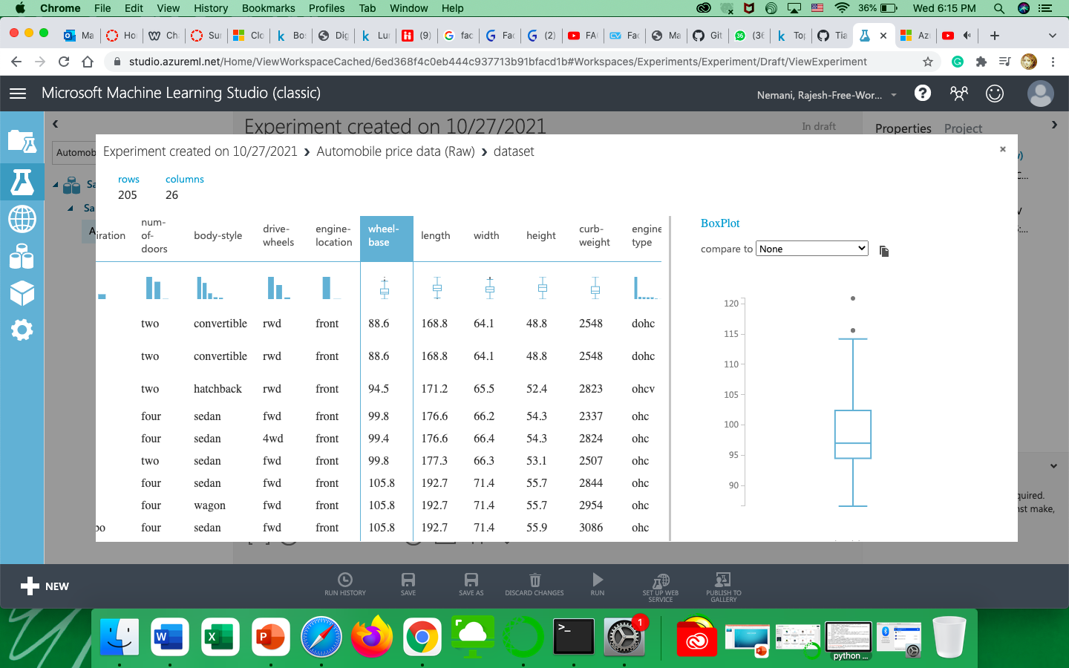

Comparing 2 different features and representing it in the scatter chart as below:

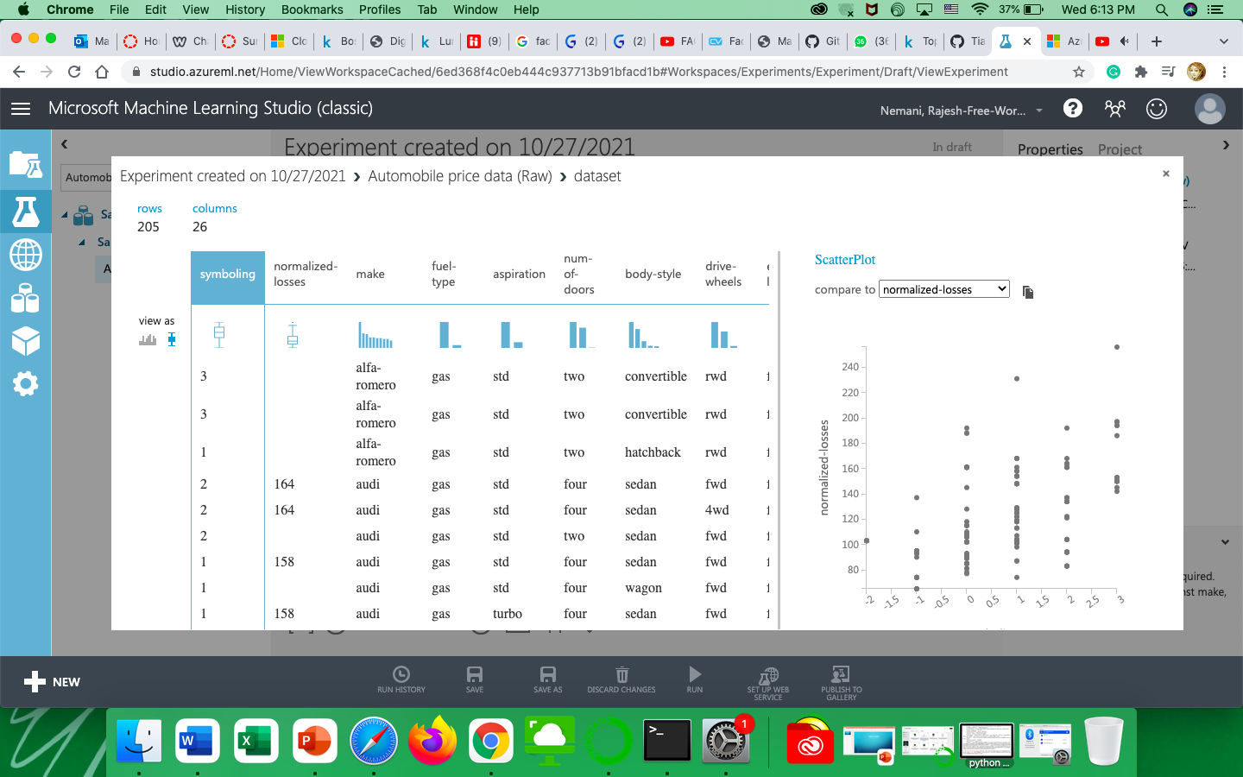

# Data Preparation:

15) In search bar search for clean missing data and take the output of dataset as the input for the clean missing data and run it, as shown in below screenshot.

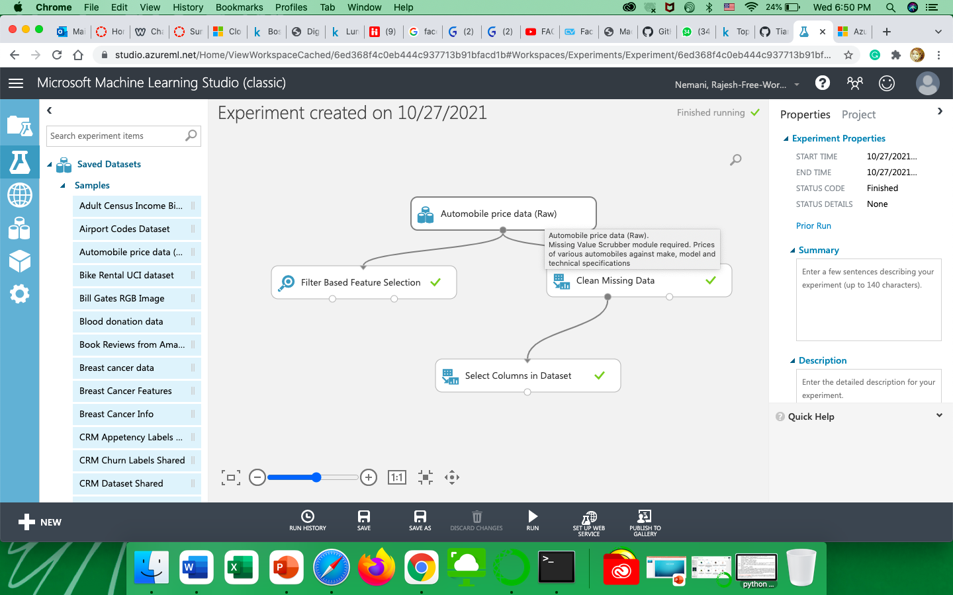

16) In search bar search for Filter Based Feature Selection and drag it and drop it on the page, later connect the output port of the first module i.e, dataset module to the input for Filter Based Feature Selection module, the select the value as price later, let it run. Once it has run successfully it would give a green tick beside the module. Now click on the module and click on the data displayed.



That would result in the following result:-

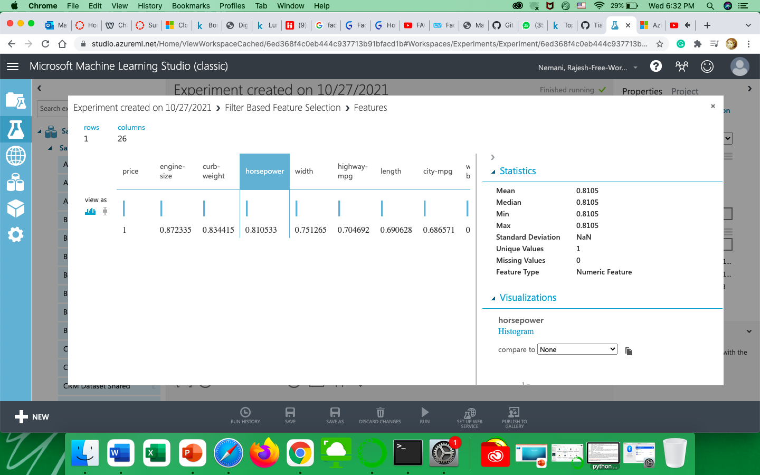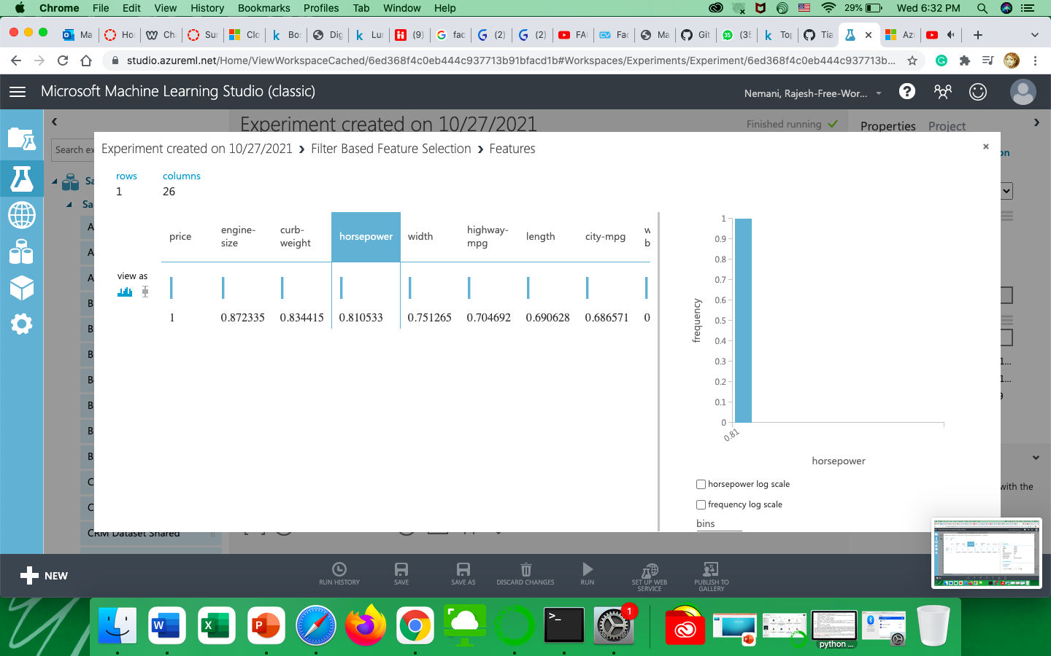

18) Enter “Split Data” in the search bar and drag and drop “Split Data” into the workspace. On the right-hand side enter 0.67 in the Fraction of rows in the field. Be sure Randomized split is checked and enter 7 for Random seed. Leave False for the Stratified split. Connect “Select Columns in Dataset” to “Split Data”.

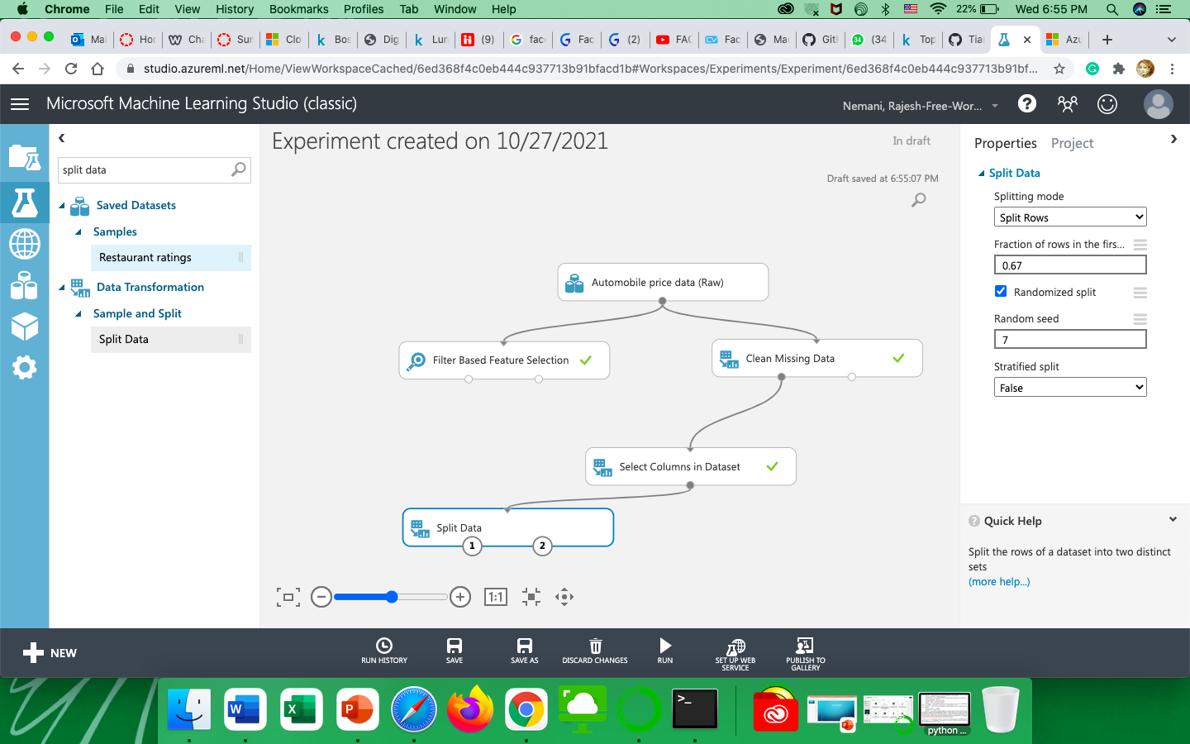

19) now we will connect the Linear regression model and run it. The output of that would be connected to train model as input 1 nd in input 2 we would connect the output of the split data and then run both the models. In train model we will predict the price, so we would select price in train model.

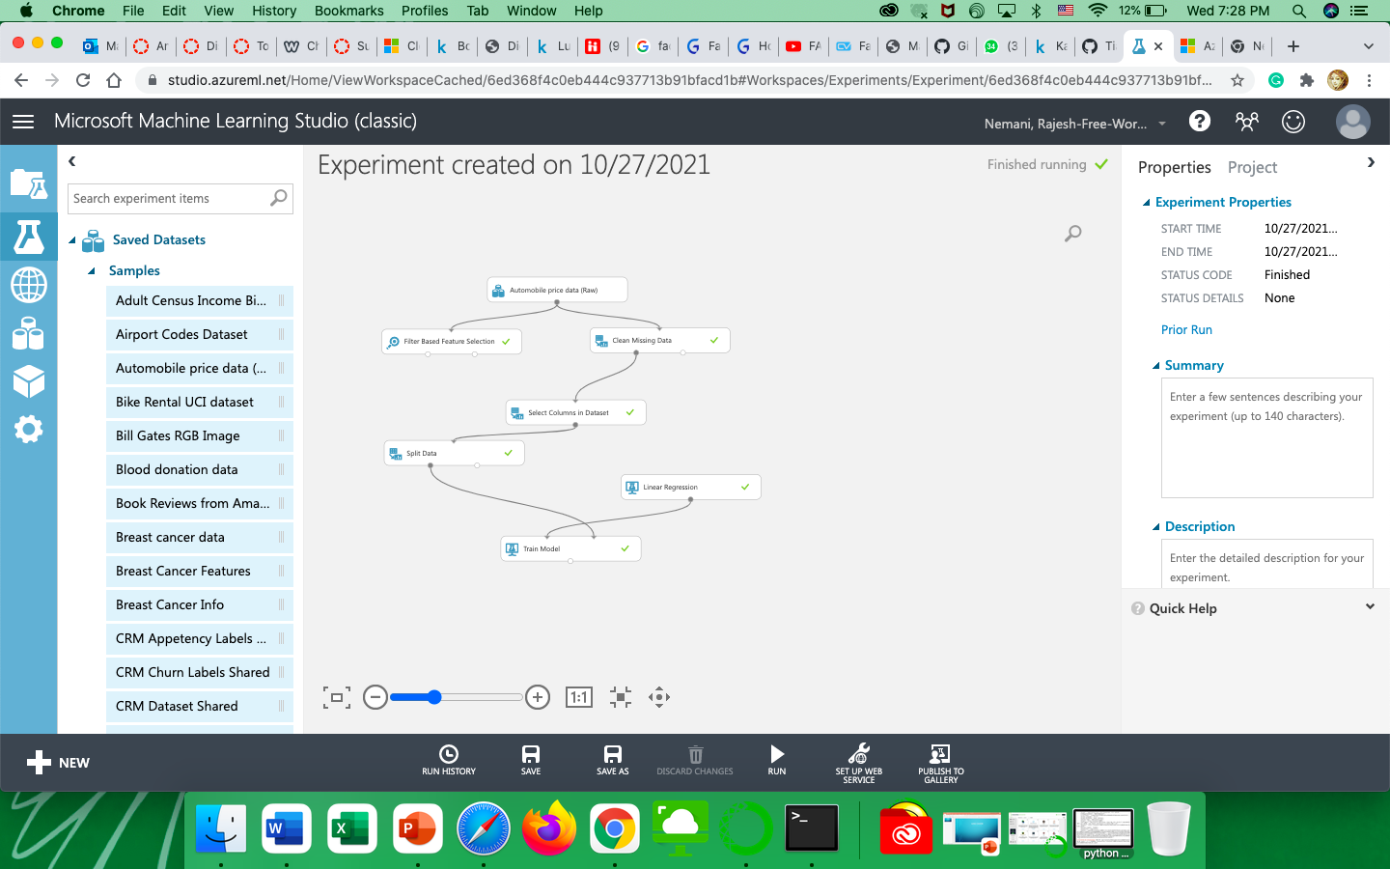

20)Now in we send 2nd part of data which we did split for the testing to the score model and also we would send the train model output as input to score model. Then run the model. Then we send the output of the score model to the evaluation model.

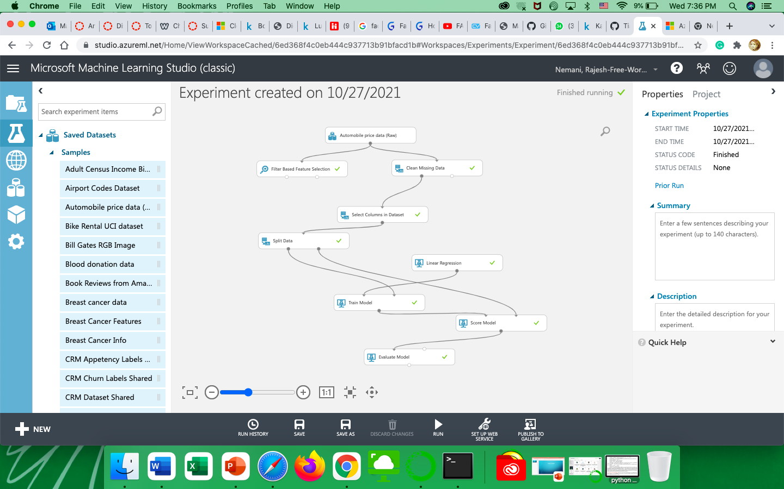

21) now we add the cross validation model and select random seeds as 7, as we have to predict the price, we would select the price in launch column selector.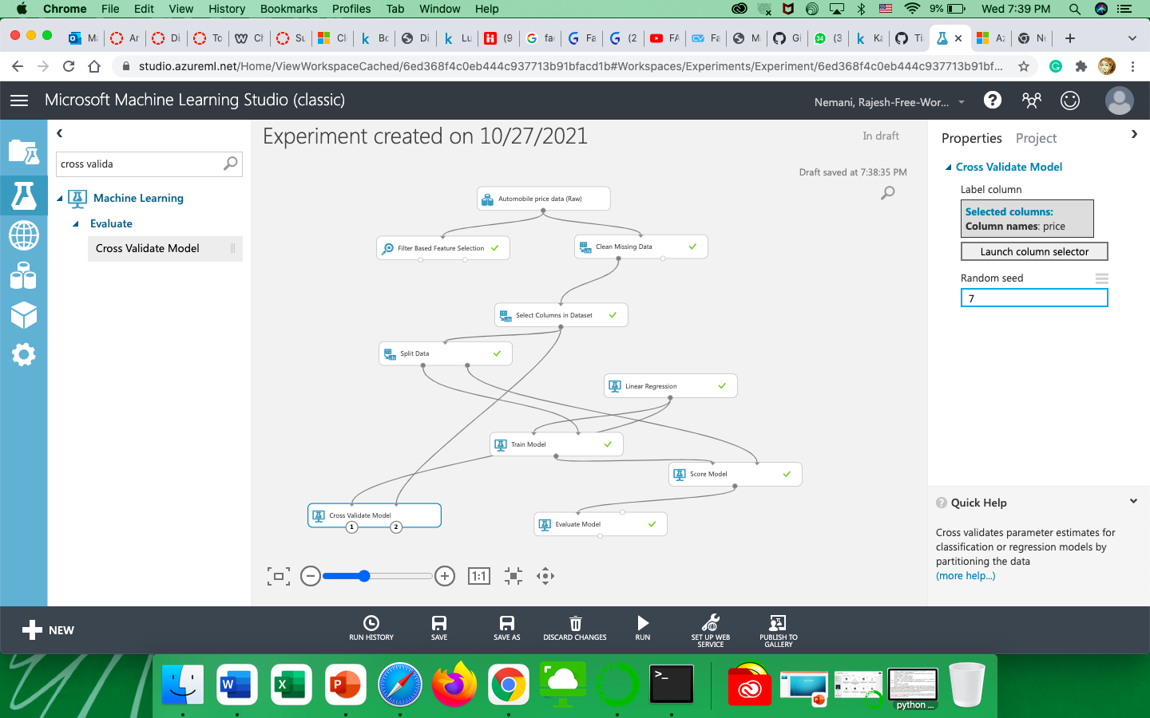

22) Now run the cross validation model. Right-click on the cross validation model and select evaluate results by fold and select visualize. Then we can find the output required.

